SPECIES BRIEFING DOCUMENT – Wildlife Crime Case Information
Copyright of The University of Hong Kong –not to be used without permission of the authors
Primary Author: Amanda S Whitfort
Details of specimens
Scientific Name | Rhinoplax vigil
Common Name(s) | Helmeted hornbill (English)  盔犀鳥 (Chinese)
Specimens Description  e.g. live, skin, carcass | Only the large and solid casque (mainly the upper mandible, but sometimes the whole skull) is traded. In the trade the species is known as hornbill ivory, golden jade, 鶴頂紅, or 紅象牙. It is carved into different items (rings, decorations, pendant, beads, etc.), much like ivory.
Quantity  e.g. head, weight(kg) | In Mainland China, seizures of over 100 casques are made, often together with other high-value wildlife contraband such as elephant ivory, rhino horn, hawksbill turtle shell and bear and leopard claws and teeth.
Trade Value Estimate  Illegal/legal trade value | US$1,000 for a single casque (Beastall et al. 2016)  In 2020 a court in Urumchi city, Xinjiang AR, valued a single casque at 8,152 yuan. Carvings made from casques were valued at 400,000 yuan by the same court.
Declared Origin of Consignment
Declared Destination of Consignment | China, Laos, Japan

Species Global Status and Threats
IUCN Red List Category | Critically Endangered | CITES Appendix | I
Country of Origin  (Natural Range) | Myanmar, Thailand, Malaysia, Indonesia, Brunei, Singapore (Locally extinct)
Major Threat(s) | Overexploitation for its casque, which is known as hornbill ivory or hedinghong 鶴頂紅in Chinese. The casque can weigh up to 10% of the bird’s body weight.  Habitat loss from logging and conversion to palm oil plantation.
Notes | The helmeted hornbill is the largest species of hornbill in Asia.  Despite being listed on CITES Appendix I since 1975, illegal trade of its casque continues to take place, and trade volume has evidently been increasing in the last decade (Beastall et al. 2016).  In 2015, the species was up-listed from Near Threatened to Critically Endangered on the IUCN Red List due to severe hunting pressure for its casque and as a result of habitat loss from logging and agricultural conversion. Hunting pressure is expected to increase and spread across the species' range given the value that is placed on the casque in illegal trade.  Grade 1 nationally protected species in China.

Victim Impact Statement (Country of Origin)
e.g. Ecological/Social/Economical Impact to the country of origin
As one of eight hornbill species native to Borneo, the species is important in the culture of many ethnic groups on the island. It has been associated with head-hunting and the afterlife and is the state bird of Indonesia’s West Kalimantan province (Beastall et al. 2016).

Hornbills eat fruit and are the largest and most effective seed dispersers in tropical forests, known as “forest engineers”. Hornbills are “high quality dispersers” because they eat only the fleshy part of the fruit and the seeds have short passage time in the gut. Hornbills in Asia transport seeds of over 700 species, and also spread them far across the forest and produce even spread of the seeds and new trees. (Kitamura, 2011).

Their role of forest engineers makes them an important species for facilitating forest recovery in Southeast Asia, where forests are disappearing rapidly to give way to palm plantation and agriculture conversion.

Severe population declines have been reported from most of the species range, including Sumatra, peninsula Malaysia, and most of Borneo, mainly due to poaching and habitat loss. The poaching is centered on Indonesia currently, but expansion to Malaysia is also suspected as the population declined in Indonesia (S. Mahood per. comm. in IUCN Red List). Between March 2012 and August 2014, 1,117 and 1,053 heads/casques were seized in Indonesia and China respectively during enforcement actions (Beastall et al. 2016). In West Kalimantan, it is thought that as many as 500 birds were being killed every month in 2013, resulting in an annual loss of 6,000 individuals (Hii 2015). Analysis of seizure data by UK-based NGO Environmental Investigation Agency (EIA) shows at least 2,878 helmeted hornbill casques, skulls and products were seized from at least 59 known confiscations between 2010 and 2017.

Victim Impact Statement (Local)
e.g. Ecological/Social/Economical Impact to Hong Kong
This species is not native to Hong Kong.

Wildlife Welfare Concern
e.g. Specimen’s health/transport condition, cruel poaching/slaughtering practice
Hunters usually target the casque bearing males, but because of the unique breeding cycle of hornbills (where females and chicks completely rely on males to provide food to them while being incarcerated in tree holes), the killing of males can lead to deaths of both females and chicks.

Disease and Pathogen Concern to Human and Local Environment
e.g. Carrier of zoonotic disease/pathogen/parasite
Not applicable.

Wildlife Forensics
Dr Chloe Hatten, Dr Caroline Dingle and their collaborators from the University of Hong Kong and the National Research and Innovation Agency of Indonesia have developed a forensically validated and standardised test for the species identification of helmeted hornbills from their casques, providing a rapid and robust scientific method to support evidence in court.

Relevant Previous Cases
e.g. References to previous cases of relevance, outcome, penalty, post seizure costs passed onto Government and NGOs
GLOBALLY During 59 separate events between 2010 and 2017,2,878 casques (value $US3 million) were seized. (IUCN, 2018)

Most seizures occur in Indonesia (source country) and China (destination country) with poachers in Indonesia confirming the involvement of organised crime networks who also target pangolin and tiger (Beastall, 2016).

In 2016, a man was sentenced to two months in prison and fined $5000 for attempting to smuggle 99 kg of ivory, 7 kg of hornbill casques, and 2 kg agarwood across the Hong Kong-Shenzhen border.

In August 2017, a Hong Kong man attempted to smuggle 14 hornbill casques into Shenzhen from Hong Kong via the Futian border checkpoint. The man claimed that he received 300 RMB for the offense.

HKSAR v Lin Jun Jie DCCC 294/2019 (District Court of Hong Kong)
In July 2019 a man was sentenced to 4 years in prison (reduced by 1/3 for a guilty plea) for his part in the smuggling 3 kg of hornbill (27 items) through Hong Kong.

Mainland China

In 2020, the Intermediate People’s Court of Bake District of Urumchi City, Xinjiang SAR, found defendant Tan Tao guilty of transporting, purchasing and selling valuable species and products made from them, sentencing him to 10 years imprisonment and a fine of 200,000 yuan. Since 2014 Tan Tao had been involved in illegal wildlife trade, purchasing the contraband from Vietnamese sellers or from sellers from Doumen district in Zhuhai city in Guangdong province. He was found in possession of 6 items made from helmeted hornbill casque to the value of 2,400,000 yuan and 184 casques to the value of 1,500,000 yuan.

Tao also had in his possession 81 ivory items to the value of 489,485 yuan, 58 rhino horn items to the value of 182,700 yuan, 1 Hawksbill turtle item to the value of 80,000 yuan, and 5 pangolin scales to the value of 16,000 yuan. He had also sold two pieces of elephant ivory products to the value of 26,562 and 1925 yuan respectively.
Case number: （2020）新0103刑初246号

In 2015, the Intermediate People’s Court of Shenzhen City, found defendant Dai, Hong Kong SAR citizen and a waitress in a restaurant, guilty of smuggling valuable species and products made from them, sentencing her to 6 months imprisonment and a fine of 2,000 yuan. In 2012, Dai was hired by suspect Chen to take 15 casques of helmeted hornbill into Shenzhen from Hong Kong via Louhu checkpoint. Chen paid her 400 Hong Kong dollars for the service. Dai told the court that Chen told her that the contraband was wood. The total value of the casques that weighed approximately 1kg, was estimated by the court to be 40,080 yuan.
Case number: （2015）粤03刑初147号

In 2015, the Intermediate People’s Court of Shenzhen City, found Huang Mouxing guilty of smuggling valuable species and products made from them, sentencing her to 6 months imprisonment and a fine of 30,000 yuan. In 2012, Huang crossed into Shenzhen from Hong Kong via Luohu checkpoint, with 30 hornbill casques and 0.9kg of agarwood (Aquilaria sinensis). Huang told the court that she was helping an Indonesian-Chinese man, surnamed Wei, whom she had met on a flight to Hong Kong from Indonesia. She claimed that she then bumped into Wei at Luohu border crossing and offered to help him to take his luggage through the checkpoint, because Wei was of advanced age and had a lot of luggage. The total value of the casques was estimated by the court to be 80,160 yuan.
Case number: （2015）深中法刑二初字第341号

In 2016, the Intermediate People’s Court of Xiamen City, Fujian Province, found defendant Chen guilty of smuggling valuable species and products made from them, sentencing him to 2 months imprisonment, suspended for 3 years, and a fine of 20,000 yuan. In April 2015, Chen arrived at Xiamen International Airport from Singapore and attempted to smuggle into China,16 helmeted hornbill casques and 75 teeth of Malay sun bear. The contraband was concealed in his luggage. The casques were valued by the court at 42,752 yuan and sun bear’s teeth at 95,000 yuan.
Case number: （2016）闽02刑初30号

In 2018, the Intermediate People’s Court of Putian City, Fujian Province found Huang Xing guilty of transporting, purchasing and selling valuable species and products made from them, sentencing him to 8 years imprisonment and a fine of 40,000 yuan. Huang purchased wildlife products online then processed them by hand and sold. The illegal wildlife products seized from Huang included 138 pieces of helmeted hornbill casque (beads and left-over fragments), 26 bear’s teeth, 45 leopard teeth and 14 leopard claws. The total value was estimated by the court as 211,815 yuan.
Case number: （2018）闽03刑终303号

Further Expert Comment
e.g. local knowledge about species, future conservation concerns, invasive risks, IUCN/CITES up-listing proposals
Beastall C, Shepherd CR, Hadiprakarsa Y, Martyr D. 2016. Trade in the Helmeted Hornbill Rhinoplax vigil: the ‘ivory hornbill.’ Bird Conservation International 26:137-146.

BirdLife International. 2016. Rhinoplax vigil. The IUCN Red List of Threatened Species 2016: e.T22682464A92947540. http://dx.doi.org/10.2305/IUCN.UK.2016-3.RLTS.T22682464A92947540.en. Downloaded on 18 May 2017.

Collar NJ. 2015. Helmeted Hornbills Rhinoplax vigil and the ivory trade: the crisis that came out of nowhere. Birding ASIA 24:12-17.

Hii R. 2015. Helmeted Hornbills on the Verge of Extinction. http://www.huffingtonpost.com/robert-hii/helmeted-hornbills-on-the_b_6804302.html

Kitamura S, 2011. Frugivory and seed dispersal by hornbills (Bucerotidae) in tropical forests. Acta oecologica. Vol.37 (6), p.531-541

Illustration/Photographs (if available)
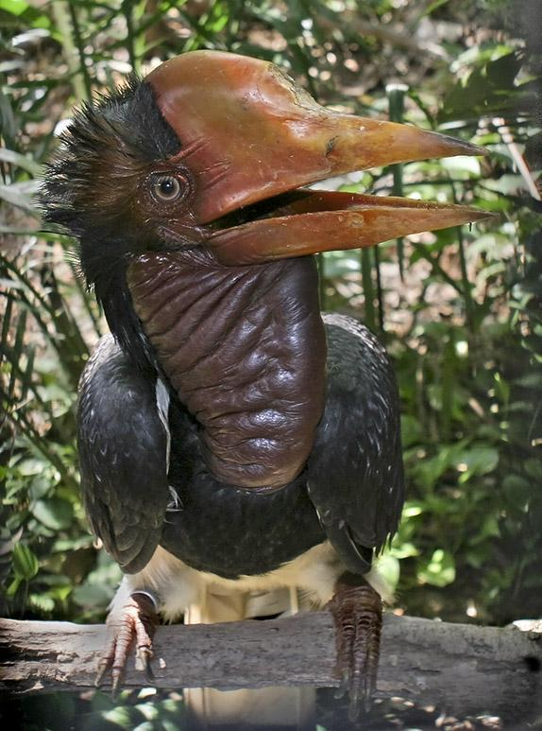
(Wikipedia Commons)
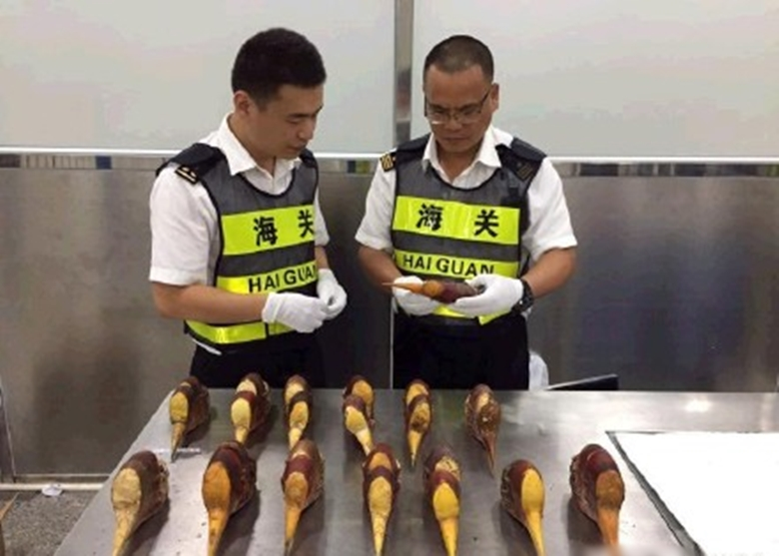
(中新网)
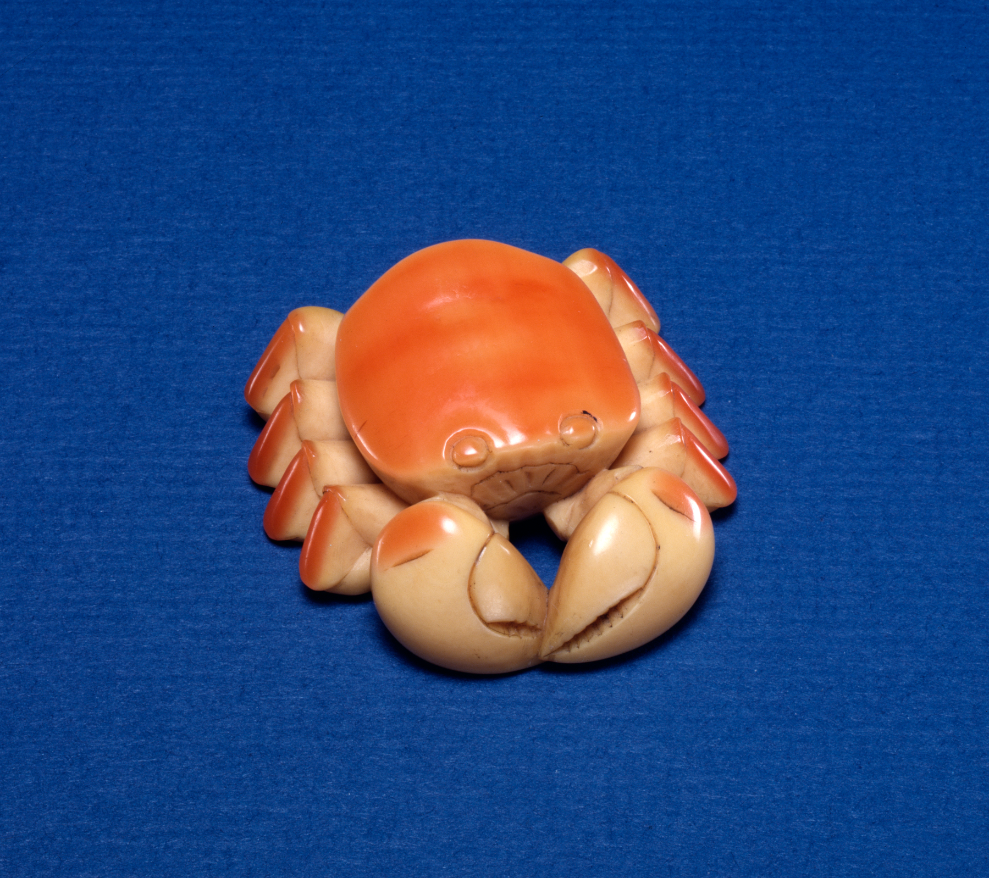
(Wikipedia Commons)

END

